MBL – John Muir High School Field Trip
Finding the beauty of microbial diversity
Short  Descriptions | This is an inquiry-based field trip where students will explore microbial life on Earth.
Related  Standards  (NGSS) | HS-LS2-3  Construct and revise an explanation based on evidence for the cycling of matter and flow of energy in aerobic and anaerobic conditions.  ESS2.E Biogeology  The many dynamic and delicate feedbacks between the biosphere and other Earth systems cause a continual co-evolution of Earth’s surface and the life that exists on it.  Besides these Earth Sciences standards, the trip also incorporates Native American Indigenous history.
Learning Outcomes | By the end of the field trip, students will be able to:  - Construct a way to visualize the microbial world with the naked eye  - Practice and value “Leave No Trace” ethics when visiting the outdoors
Duration | 9 am - 2 pm (5 hrs)
# students | 20
Location | Arroyo Seco/Gabrielino Trail (first 0.6 miles):  https://goo.gl/maps/Kz7AvVw5pkfJiny7A  NEED A PERMIT – For community outreach/citizen science:  Angeles N.F. Arcadia office: 747-322-6574  (ask for wildlife biologist)
Materials and Equipment | - Name tags for each student and markers  - Markers to write on agar plates (streak plate)  - Sleeves of pre-poured agar plates (2 per student plus a handful of extras)  - Plastic container for each student's Winogradsky column  - Trowels  - Field guide & pencil for each student (attached)  - LUNCHES? & Trash bag  - Snacks provided by GO Outdoors  - First Aid Kit  - Map  - Roll of paper towels  - Hand sanitizer  - Extra water for muddy hand washing  - Optional: Other guides or local birds / plants
Accessibility | This trip includes walking on uneven surfaces. The main trail is generally wheelchair accessible, but does not go down to the river. This trip also includes visual and tactile observations.  Bathrooms are not available nearby during the duration of the trip.
Safety Awareness | Mountain bikers (and occasionally equestrians) share the San Gabrielino trail with hikers and they can be very fast. The San Gabrielino trail is also quite popular and can often be crowded.  Other potential hazards include:  - uneven ground, potential trip hazards & slippery rocks near water  - stream-related safety (near water)  - poisonous & sharp plants (including poison oak)  - wildlife (includes rattlesnakes, mountain lions)  - sunburn/heat illness
GO-Outdoors Missions | At GO-Outdoors, we emphasize the following missions:  - Instructor/Caltech volunteers will pack the Ten Essentials and incorporate Leave No Trace ethics into their planning and behavior on the trip. These concepts should be made approachable so that students are encouraged to adopt them on their own.  - We are looking forward to tailor our trips to student interests. At the start of each of our trips, we will ask each student to share what they hope to learn and we will try to incorporate them into the field trip.  - All of our field trips will feature a safety scavenger hunt, “Escape from Danger”, in the booklet that will raise students’ awareness on hazardous plants and wildlife in nature to build confidence in exploring the outdoors.
Field trip activities

This is a full day field trip and requires a bus to transport students to the trail. The following schedule is based on a fieldtrip between 8:30am - 2:30 pm.
---------------------------------------------------------------------------------------------------------
WEEK BEFORE TRIP:
-Send Teacher pre-trip survey (what you know before the trip)
-Ask teacher to tell students before the class that it will be a long trip without an indoor/official bathroom (no porta-potties). Students should be asked to use a bathroom beforehand.
-Let teacher know rough schedule (when GO-Outdoors folks will arrive at Muir, when bus will arrive/depart, snack & lunch time and providers.)

---------------------------------------------------------------------------------------------------------

FIELD TRIP SCHEDULE

8:30 - 9:00 AM: Meet teacher @ John Muir High School –Alexandra Gonzales (There are restrooms 1.3 miles from the JPL entrance/trailhead area at Hahamongna Watershed Park.)

9:15 - 9:30 AM: Pass out name tags and load bus **INCLUDES BATHROOM TIME!** Make name tags on bus!
Pre-trip survey

~9:50 AM: Unload @ trailhead!
Introduction (10 mins)

Students meet at JPL parking lot (Stop 1 in the field guide). There should be plenty of space for parking here. Do not enter JPL. The San Gabrielino trail begins just north of this parking lot. (https://www.google.com/maps/place/JPL+Parking+Lot+Entrance/@34.2029938,-118.168572,17z/data=!3m1!4b1!4m5!3m4!1s0x80c2c264f77f86cb:0xc329cfa1945d077b!8m2!3d34.2030017!4d-118.1663808)

- Explain Schedule (hike, snack, hike, lunch, back by 1 pm)
- Hand out the field trip guide booklet and discuss safety and guidelines for the hike. Discuss the “Escape from Danger” scavenger hunt activity where students can check a box when they find and identify certain plants and wildlife (e.g., poison oak) while maintaining a safe distance from them.
  - Describe the goal of the field trip, which is to understand that:
    - Life exists without oxygen
    - Life is diverse
    - Making the microbial world apparent to the naked eye!
- LEAVE NO TRACE: 7 principles in the booklet – reference throughout the day
- ON LNT & SAMPLING: we have permit from National Forest to leave this small trace, in the name of Community Science!

---------------------------------------------------------------------------------------------------------
10:00 AM
20 mins hiking– stop, find a shady area,
~10 min SNACK– talk about the history of the region:
- Mention the history of the trail and the river, comparing those documented by Tongva and the modern history. Tongva, the indigenous people to this area called the area “Hahamongna”, which means “land of flowing water”. In contrast, the Spanish settlers called this area “Gabrielino” after the San Gabriel Mission. The stream in this area is called “Arroyo Seco,” which means dry river in Spanish. This contradiction points out one of the themes for the field trip -- life changes (and evolves) over time.

~5 more mins Hike to area with social trails down to stream, along by the fault & concrete slope, where sampling/lesson will occur

---------------------------------------------------------------------------------------------------------

10:35 AM - 12 PM

- Icebreaker activities? – idea: “Think Like A Scientist” activity: happens during the hike, or right at the start of the trail, introduce at the start – relate to students about scientists asking questions and coming up with ways to answer those questions by testing hypotheses. Have students (as they hike, or take ~5 minutes) look around on the trail for things they wonder about. What is their question? What would they do to try to answer the question? When you come back together as a group, have students (either think-pair-share or small groups) share with each other what they wondered about, what question they wanted to ask, and how they’d start to try to answer. Come back together as a group, and share these questions.

Split into 3 groups
20 minutes per group

Group 1 (Agar plates): Explain that there are microbes on just about every surface on earth. Although these organisms aren't typically visible to the naked eye, if they encounter the right conditions, they will form colonies large enough for us to see. This is a good time to ask students what "the right conditions" might look like and compare it to their own lives: (nutrients, temperature, oxygen??, population density, water, poisons, etc.). Explain that sterile LB/5YE agar plates provide many nutrients as well as water and a competition-free zone perfect for microbial growth. Encourage the students to come up with their own questions about what to streak on the plate (Challenge them to come up with a material to streak that DOESN'T have microbes on it!) and ask them to jot down a prediction of what the plate might look like in a week. How many cells does it take for a colony to become visible?

Group 2 (Foldscopes):
Explain that microbes are present all around us. We can visualize their world, and possibly even the microbes themselves, at high magnifications using microscopes. Encourage the students to explore their surroundings with a foldscope and take a look at whatever strikes them: rocks, plants, water, soil, clothing, their own fingers, etc.

As a wrap-up activity before sending the group to the next activity, have students explain one thing they saw that captured their attention. What did they think it was? Did they have any questions about it?

Group 3 (Winogradsky sampling):
Discuss the plan to create Winogradsky columns. Ask students what they think will happen if they stir some dirt into a jar with some nutrients and wait a month. Where do they think microbes live in the environment? Why can't we typically see/detect them in the environment (Because they are so small and often live in dilute systems)? What would allow us to see/detect them (in addition to sight, students might think of smelling something like hydrogen sulfide gas or other rotten smells associated with microbial growth)? Explain that we need to collect some soil to inoculate (will need to define this word) their columns. Have students collect their own samples and place them in their own plastic jars.

12:00 LUNCH – Summarize experience – what you just did, talk about what you saw:
- What did you see with fold scope?
- What did you choose to streak on streak plate?
- Where did you gather your mud? (how many spots?)
- Did you smell, see, notice anything when gathering mud?
- Recall Winogradsky columns – that is what you’ll be doing with this mud!

Explain that now we all will need to hike back & get to bus by 1 pm
12:30 - 12:45? – cleaned up & ready to go!
---------------------------------------------------------------------------------------------------------
(~25 mins) Hike back to the bus!

1-1:15? pm -- Debriefing – by parking lot or on bus (15 mins)

- Surveys
- Explain that we will be back in the classroom in ~1 week.
---------------------------------------------------------------------------------------------------------
1 or 1:15 – load bus (confirm with Ryan Flores?)

1:10 – leave Arroyo Seco
1:30 – back @ school, unloading & back in the classroom!
---------------------------------------------------------------------------------------------------------

Optional extension activities
- Literary/narrative relevance in Native American stories/creation stories:
http://socalstorytelling.blogspot.com/2012/11/the-tongva-people.html

Instructor support

About the Arroyo Seco Watershed:
- https://www.arroyoseco.org/ASWRFSVolI.pdf
Human history in this area can be found under the topic “Landscape Change Through Time”. The indigeneous history is labeled “Pre European Settlement” in classic erasure-language style..!):

About microbial diversity:

Vocabulary terms:
Microbe:
Agar plate:
Culture:
Nutrient (in context of microbes):

Watershed: Land that separates waters flowing to different rivers or seas.
River channel: The carved path where a river currently flows or once flowed.
Sediment: solid material (particles, like sand, gravel, boulders) that is moved and deposited in a new location.
Erosion: The action of surface processes that remove sediment, soil and rock from one location on Earth’s surface and transports it to another location.
Deposition: The action of adding sediment, soil and rock to a landform.
Debris flow: A moving mass of loose mud, rock, and water that travels down a slope due to gravity.

Common misconceptions about the concepts

- Microbes are all bad
- Dead microbes are not dangerous
- E. Coli bacteria are all the same and all bad
- Mold causes lots of problems
- Microbes affect everyone in the same way
- The only way scientists learn about microbes is by using petri dishes/cultures in a lab
- Streams are just water flowing (without any sediments)
- Human activities cannot affect geologic processes
- Floods are rare/atypical (not normal fluvial processes)
- There is no connection between surface water & groundwater
- Students may think that geologic processes all happen rapidly (including tectonics—e.g., rifting would rip them away from the USA…) OR tectonic movements are imperceptible on human timescales
- Parts of California will break off and fall into the ocean.

Opportunities to engage students in planning

- Bring along some local field guides so that students can look up plants/animals they find that they are interested in
- Answering unanswered questions on the walk back from the trip—follow-up with any that cannot be answered right then!

Provided Handouts/Materials

At the end of this field guide, we are providing the following handouts and materials:

- Pre and post trip surveys, to print for each student (or, via teacher?)
- “Microbial Diversity Field Trip Guide” booklet to print and assemble for each student

BELOW: Field guide from past trip, to pull from for this guide!
Finding the beauty in microbial diversity: Pre-Survey
Topic | How much do you know right now, before the lesson?
 | Nothing | A little | Some | A lot
Some life on Earth can exist without oxygen.
There is lots of diversity among microorganisms on Earth.
There are ways to observe microbial life with my eyes.
It is important to Leave No Trace in the outdoors.

Finding the beauty in microbial diversity: Pre-Survey
Topic | How much do you know right now, before the lesson?
 | Nothing | A little | Some | A lot
Some life on Earth can exist without oxygen.
There is lots of diversity among microorganisms on Earth.
There are ways to observe microbial life with my eyes.
It is important to Leave No Trace in the outdoors.

Topic | How much do you know right now, before the lesson?
 | Nothing | A little | Some | A lot

Finding the beauty in microbial diversity: Post-Survey
Topic | How much do you know now,  after the lesson? |  |  |  | How much did you like learning about this topic?
 | Nothing | A little | Some | A lot | Dislike | Like | Love!
Some life on Earth can exist without oxygen.
There is lots of diversity among microorganisms on Earth.
There are ways to observe microbial life with my eyes.
It is important to Leave No Trace in the outdoors.

Finding the beauty in microbial diversity: Post-Survey
Topic | How much do you know now,  after the lesson? |  |  |  | How much did you like learning about this topic?
 | Nothing | A little | Some | A lot | Dislike | Like | Love!
Some life on Earth can exist without oxygen.
There is lots of diversity among microorganisms on Earth.
There are ways to observe microbial life with my eyes.
It is important to Leave No Trace in the outdoors.

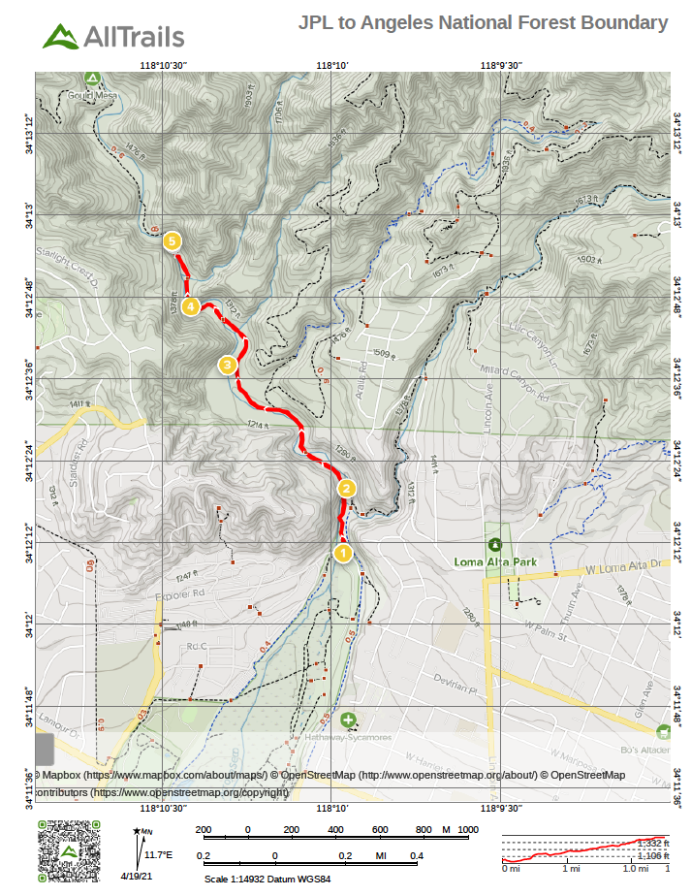

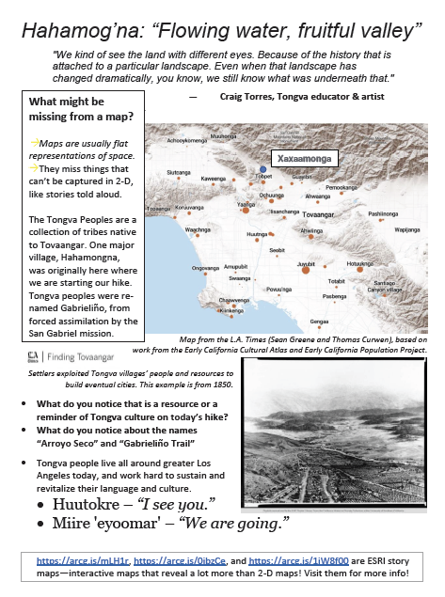

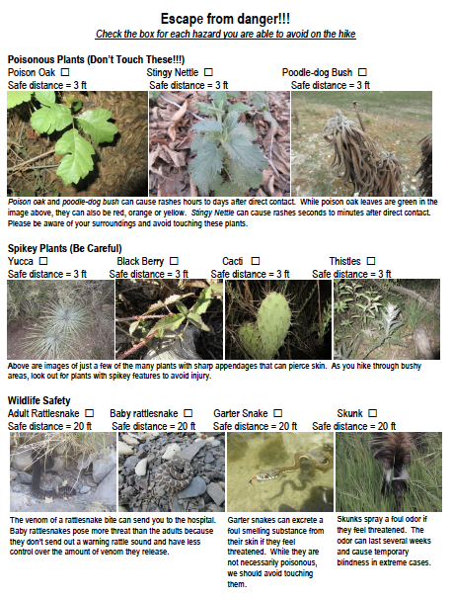

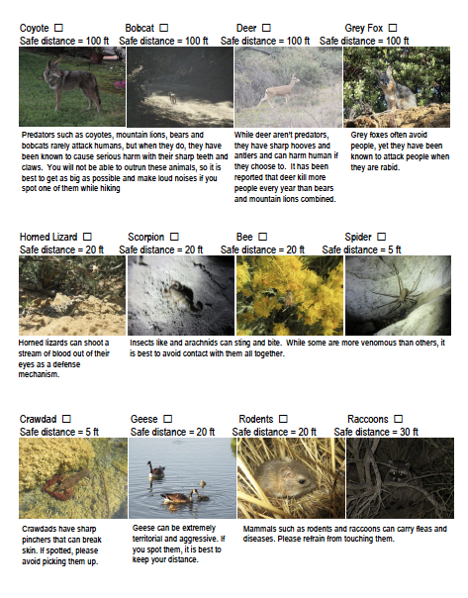

THE TEN ESSENTIALS
For safety, survival, and basic comfort
1. Navigation: map, compass, GPS
2. Sun protection: sunscreen, chapstick, sunglasses 3. Warm clothing: jacket, pants, etc.
4. Light: headlamp/ flashlight, batteries
5. First-aid supplies
6. Fire: matches or lighter
7. Repair kit and tools
8. Food
9. Water
10. Emergency shelter: tent, tarp, reflective blanket
GEOLOGISTS’ TOOLBOX
Geologists’ supplies in addition to the Ten Essentials
1. Notebook, pen, pencils and paper
2. Measuring tape / ruler
3. Hand lens
4. Hammer
LEAVE NO TRACE
Seven principles to follow when hiking
1. Plan ahead and prepare
2. Travel and camp on durable surfaces
3. Dispose of waste properly
4. Leave what you find
5. Minimize campfire impacts
6. Respect wildlife
7. Be considerate of other visitors
Source: REI.

