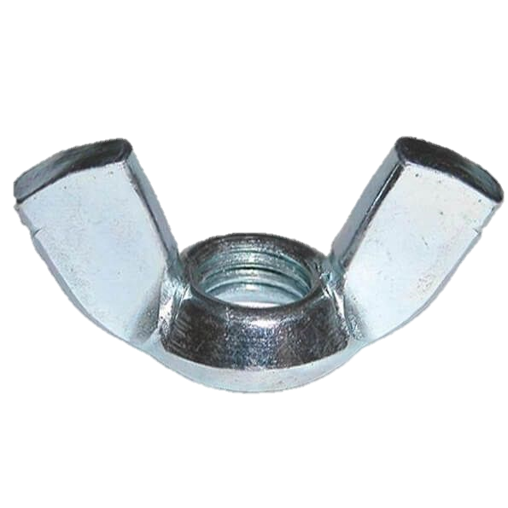
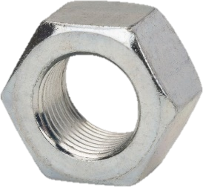
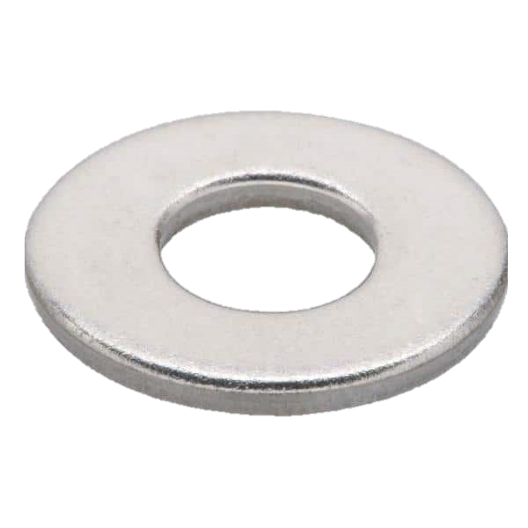
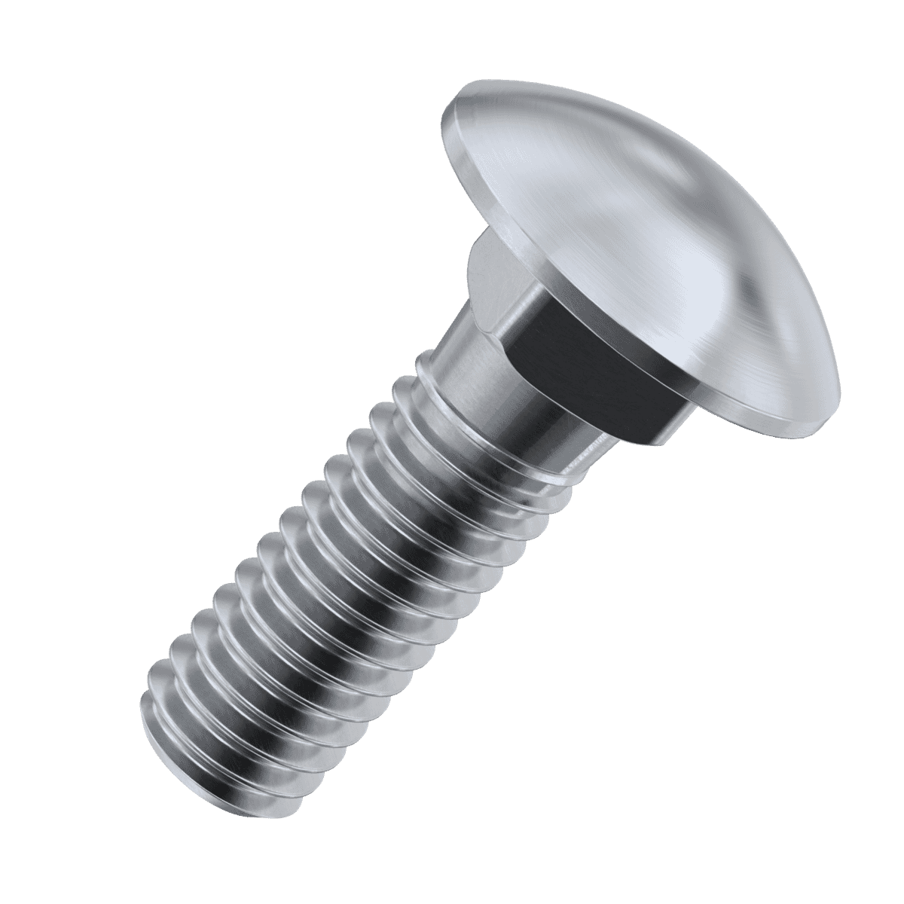
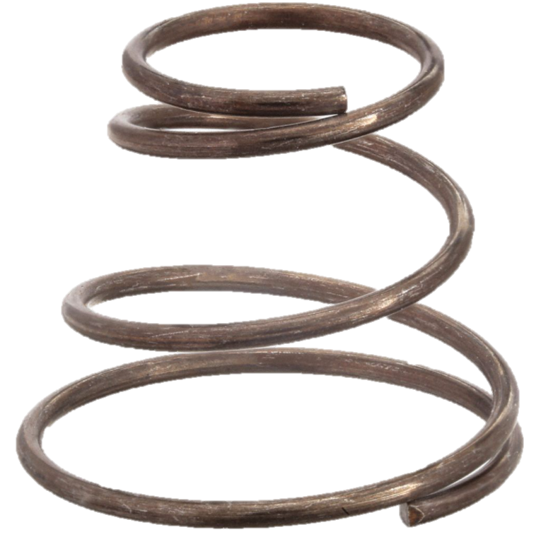
Instructions for building your DIY microscope
2x wing nut
9x hex nut
3x washer
3x carriage bolt
2x spring
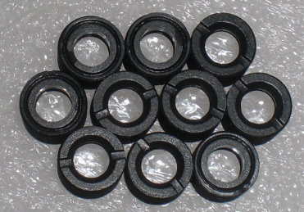
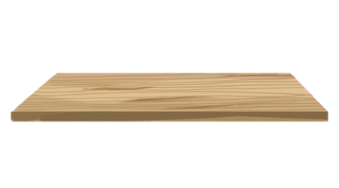
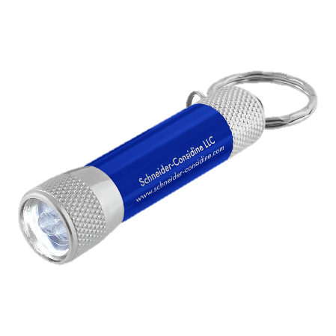
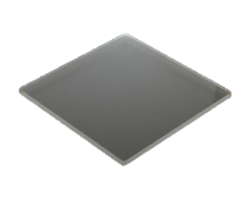
Microscope kit contents:
1 x flashlight
1 x lens
1 x wood
1 + 1/3 x plexiglass
3x washer
2x wing nut
9x hex nut
2x spring
3x carriage bolt
- Put all three carriage bolts through the three holes in the wood – the bolt should be facing upwards:
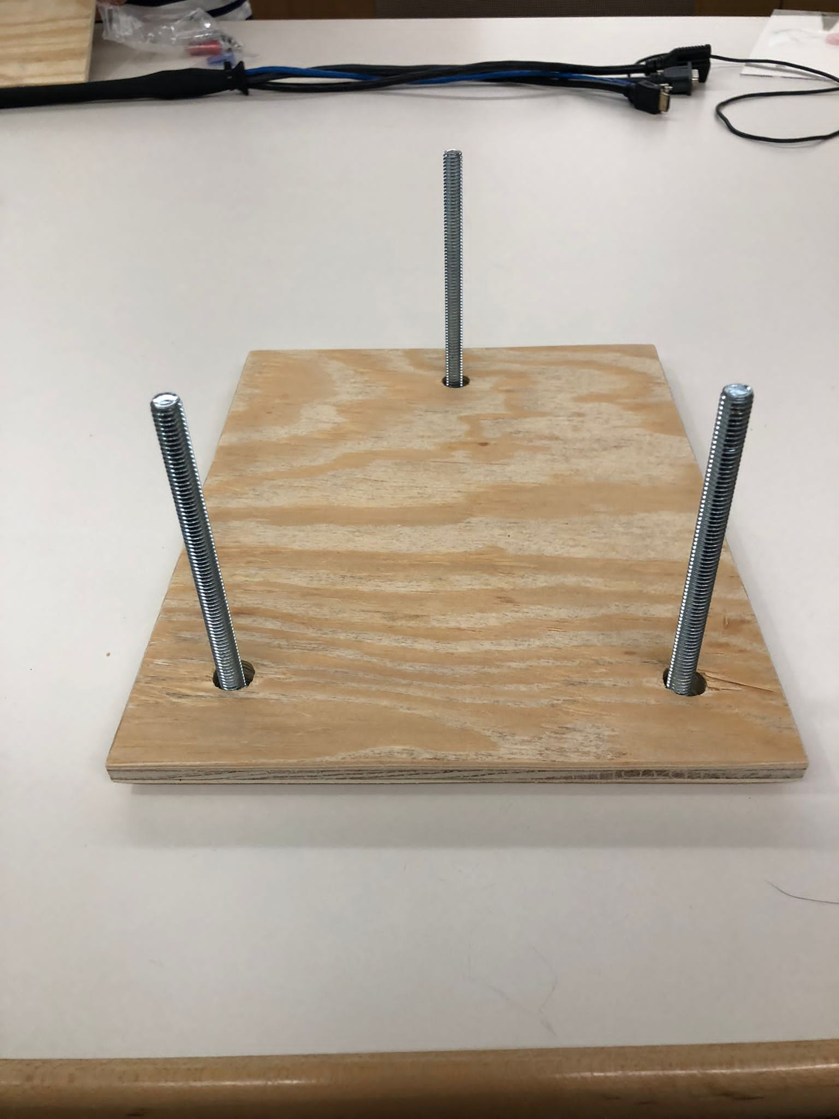

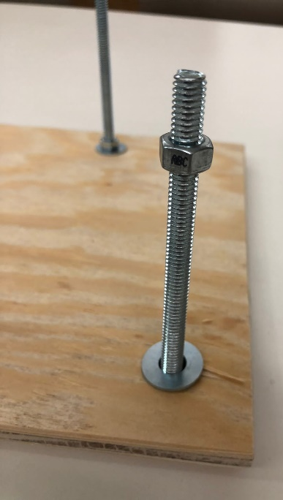
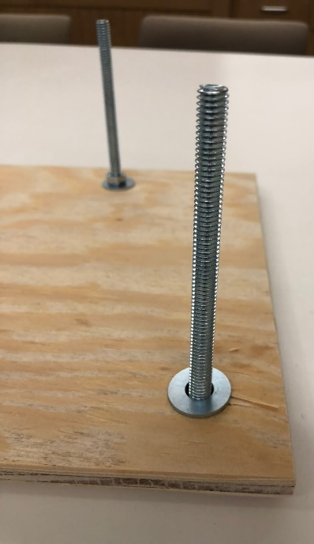
- Put the washer onto each of the bolts and secure washer with hex nut. Repeat for each carriage bolt. Tighten fully.
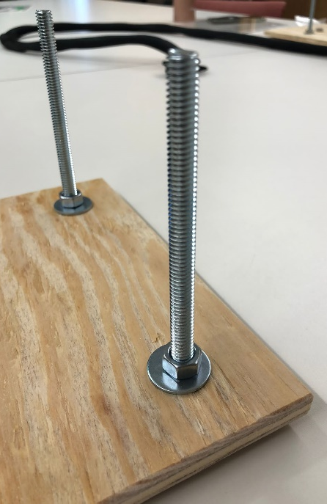

- Add wing nut to the two carriage bolds that are next to each other at the same end (no wing nut is added to the lone carriage bolt at one end). Wing faces down.
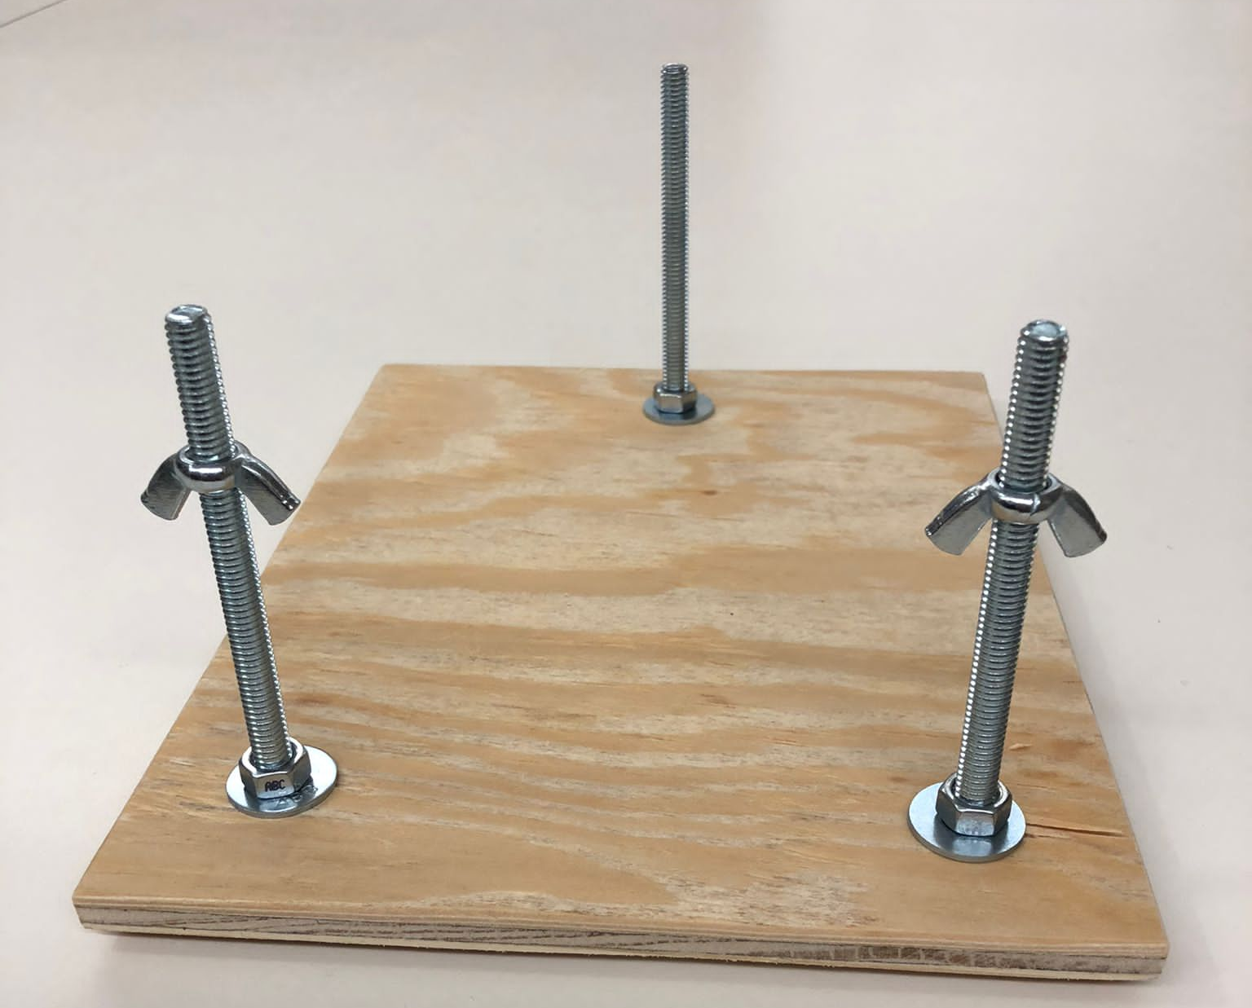

- Take the small (1/3rd) piece of plexiglass and balance it on top of the wing nuts
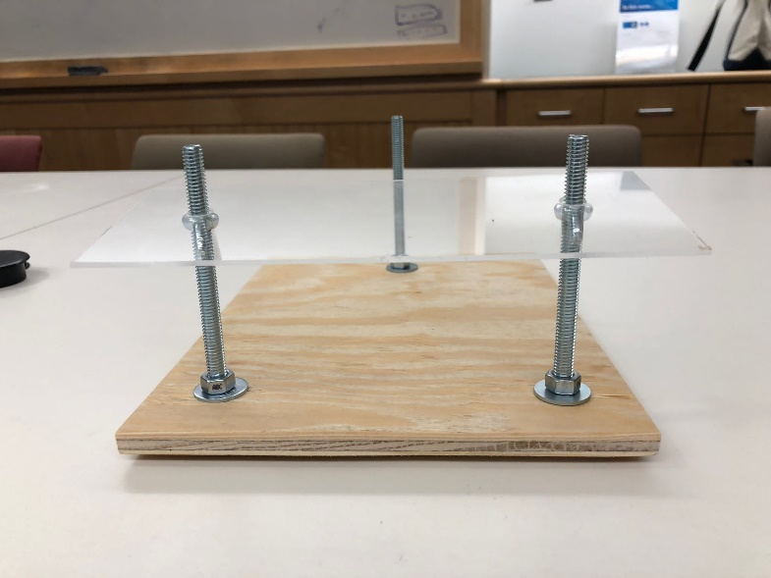

- Put a spring on top of the plexiglass over both wing nuts and add another hex nut on top of each spring. Tighten fully (later you will use the wing nuts to move the plexiglass up/down to focus your sample)
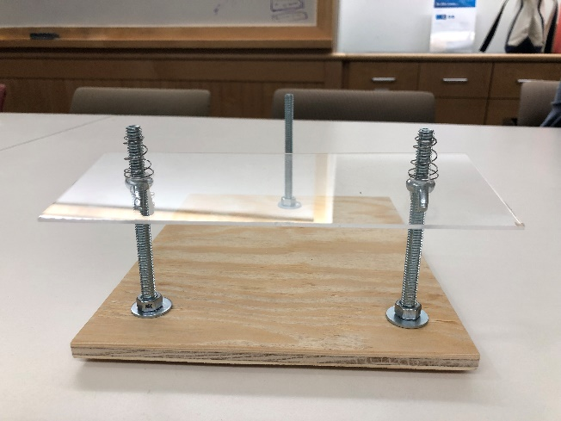
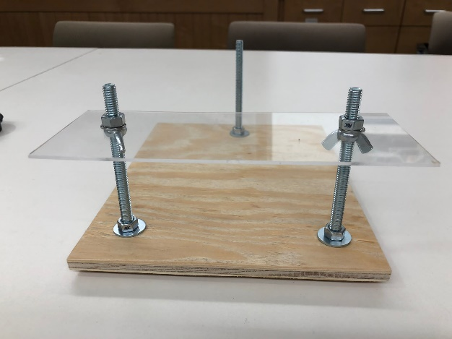

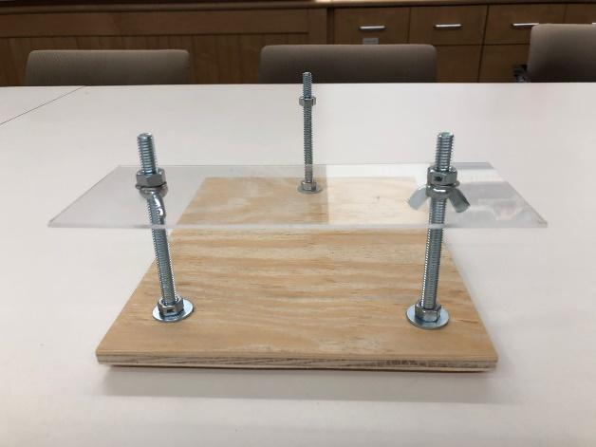
- Add another hex nut to the third carriage bolt so that it is the same height as the other nuts

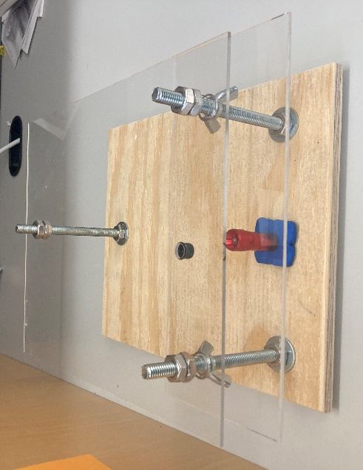
- Balance the large piece of plexiglass over the three hex nuts (lens should face down). Use three more hex nuts (orange arrow) to secure the plexiglass by tightening the hex nuts over all three carriage bolts

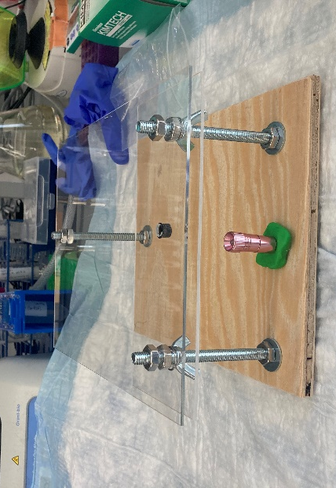
- Use clay to hold flashlight below the objective

- Put sample on small piece of plexiglass (above the light, below the objective). Put phone or ipad camera so that it is in a direct line with the objective and light source and start imaging!

