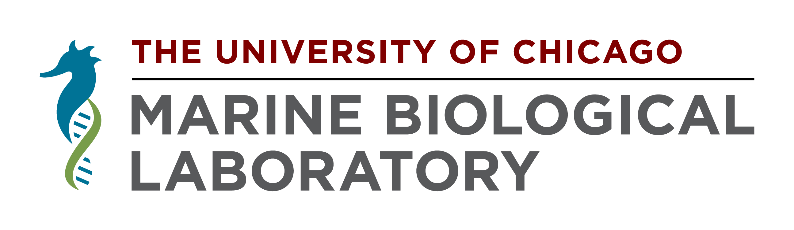
Institutional Animal Care & Use Committee
MBL
7 MBL Street
Woods Hole, MA 02543
USA
p: 508.289.7173
f: 508.289.7900
iacuc@mbl.edu

INSTITUTIONAL ANIMAL CARE & USE COMMITTEE

ADDENDUM REQUEST
TO APPROVED MBL IACUC PROTOCOLS

Protocol No. Date of Addendum Request Date of Addendum Approval

Project Title:
Principal Investigator:

Changes to be Made: (provide sufficient detail to allow evaluation by the IACUC). If request is for the addition of new responsible personnel, then include a description of the experience of said personnel for each procedure they will be involved with.

Rationale for Addendum/Modification:

If more space is needed, please attach an additional page to this form.

Date:
Signature of Principal Investigator

Date:
Signature of IACUC Chair

